Getting Started
NVIVO is a qualitative data analysis tool that assists in organising, analysing and visualising textual data.

NOTE: NVIVO for Mac does not include all of the features available in NVIVO for Windows. If you convert your Windows project and access it on the Mac platform, you may not be able to work with all your project items. For more information on the differences, and working across platforms see: https://help-nv.qsrinternational.com/20/mac/Content/projects-teamwork/work-with-projects-windows-mac.htm

Learning Objectives
By the end of this lesson, participants will be able to:
- Import and organize files
- Create Cases and Case Classifications
- Create, edit, and organize thematic Codes

Scenario and Data Overview
You have been hired to investigate what customers are saying about the grocery store, in order to allocate some funding money into improving the store.

The qualitative data that you have to answer your research question are customer reviews obtained from Google Reviews.

- Download the reviews to your computer

Log in to VPN - Working Off-Campus
In order for NVIVO to work correctly with any institutional shared drives (ie: OneDrive) you may be required to log in to a VPN. https://uoguelphca.sharepoint.com/sites/ccs/SitePages/anyconnect-vpn-user-guide.aspx

Create a new project
- Open NVIVO
- Choose Create New Project
- Follow the steps to name your project and save it to a location of your choice.
- Select Keep a log of user actions (Windows)
- Select Autosave project (check box Mac) (step 2 windows)
- Click Create Project

Note: Project file will save as .nvpx

NVIVO Workspace
When you open a project, you are presented with the project workspace which allows you to access all the tools. The Navigation View provides access to all your project items. Item folders are organised in groups:
- Data
- Coding
- Cases
- Notes
- Sets

When you click on a folder in Navigation View, its contents are displayed in List View.

When you double-click on an item in List View, it opens in Detail View.

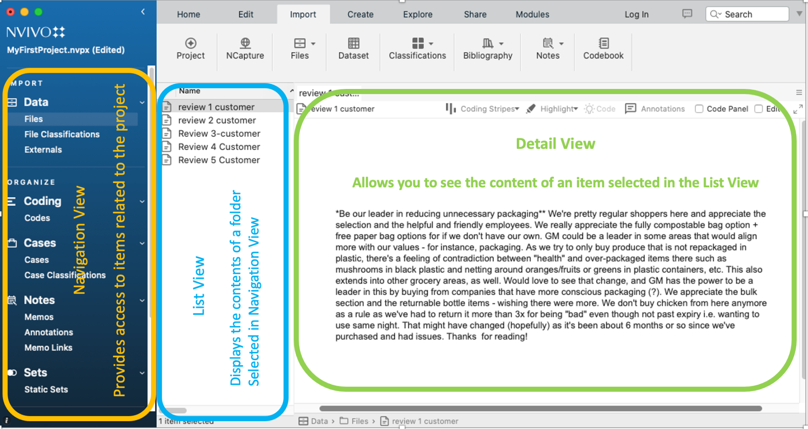

Note: This image shows the Mac version of the interface. Windows is very similar.

Organising your data:

Create folders
If you are working with different types of data (ie: reviews, interviews, surveys, audio, literature) it is recommended that you set up different folders under the Data area in the Navigation window first.

- In the Navigation Menu, Right-click on the word Files > New Folder
- Name the new folder: Reviews

Import files
- Click on the Reviews folder in the Navigation View
- Click on the Import tab > Files (Mac: then Documents)
- Browse to the files you wish to import (Google Reviews)
- Select all of the files using mouse and CMD or CTRL key to select multiple files at once >
- Import (Mac)
- Open > Import (windows)

Explore the review files
- Click on Reviews in the Navigation View to view the list of files in the List View
- Double-click on one of the reviewers to launch the text for the review in the Details View
- Repeat this process to get a sense of the reviews. Note that Kwynn has a response from the store owner. This will be important when we work with Case Classifications and attributes.

Good to Know:
- If you are working with different types of data (ie: interviews, surveys, audio, literature) it is recommended that you set up different folders under the Data area in the Navigation window first. Once the steps above are followed, then you can drag and drop the files into the appropriate folder. https://youtu.be/3cxXYyZf9sI
- Importing survey data has its own process which automatically sets up codes and cases. https://youtu.be/XrqWRsGRcyk
- Importing transcripts and audio with timestamps https://youtu.be/apD0BMcRD4w
- Importing social media data (Twitter, Facebook, YouTube) using NCapture https://youtu.be/NbAH43M-mGQ
- Importing web pages using NCapture https://youtu.be/fKeua5Ln6fQ
- Importing from desktop versions of referencing software (Endnote, Zotero, Mendeley, Refworks) https://youtu.be/8ea7mA1OfwY and https://youtu.be/mcIra2D2BR0

Cases & Case Classifications
Cases are the people, places, organisations, events, or other entities that constitute the units of analysis in a project. Not all projects require the creation of cases, however they are necessary if you want to be able to analyze your data in terms of demographic or bibliographic attributes. This is the purpose of Case Classifications and attributes. Classifications are tables that store quantitative information. You can manually create this in NVivo or import an already created table. The diagram below illustrates these relationships.

In this exercise our unit of analysis are person - the reviewers. As you will see, we know their gender, and if they received a response from the store. To link this demographic information to our reviewers so that we can later do comparative analysis we need to:

- Convert our files to cases
- Assign desired classifications, attributes, and values

Creating Cases
- Click on Files > Reviews in the Navigation View.

- Highlight all the files in the List View > Right click > Create As > Create as Cases > Ok
Note: leave everything as default.

- Click on Cases > Cases in the Navigation View to view your cases. Notice the briefcase icon next to each review.

Create Case Classification and Attributes manually
In this part of the workshop we will be creating case classifications manually. In a later part, you will learn how to import an already created classification sheet.

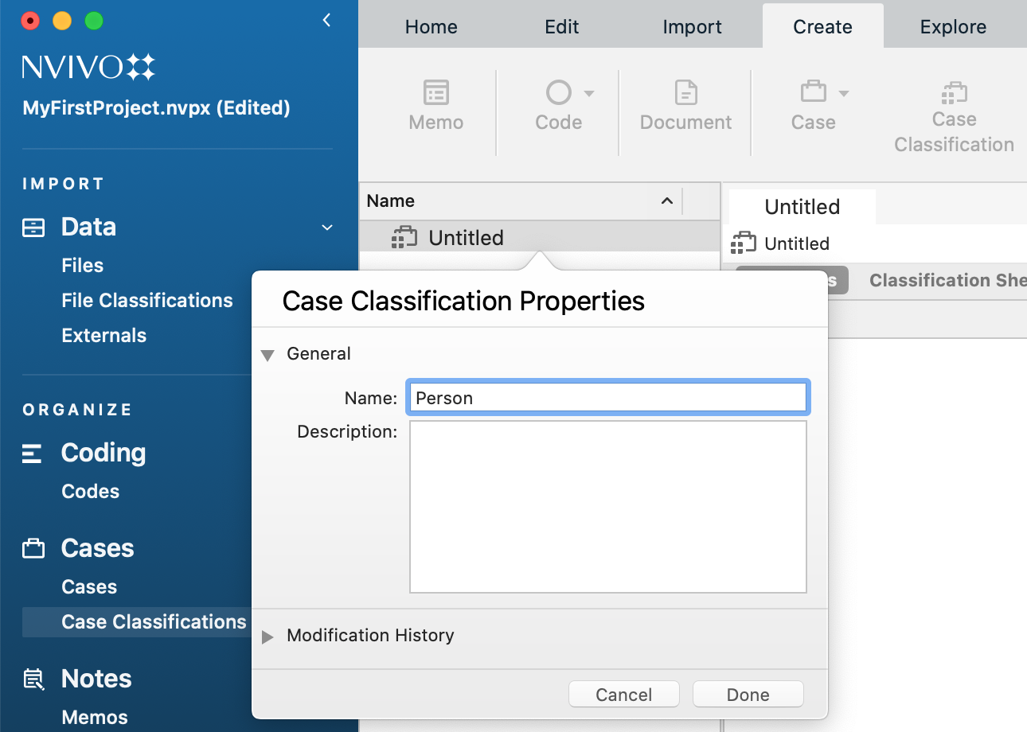
Create a new Case Classification:

- Click on Create in the top menu bar > Case Classification

- Add the name of classification. In our case we will create one called Person.

- Add description (optional) > OK / Done

Now that we’ve created a case classification, we need to add the attributes. We will be adding gender, and whether or not a reply from the owner was added.

Create attributes:
- Click on Case Classifications in the Navigation View
- Right click on Person in the List View > New Attribute
- Add the name of the attribute, in our case “Gender”
- Add description (optional)
- Select Type as Text
- Create attribute variables:
- Windows: Click on the Values tab > Add > type “female”. Repeat this step for “male” and “non-binary” > OK
- Mac: Click on the + below the Attribute Values box > type “female”. Repeat this step for “male” and “non-binary” > Done
- Repeat steps 2 to 5 to create the attribute “reply”
  - Type: boolean
  - Values should be “yes” and “no”
  - Check the box next to “no” to set it to default. This is useful when an answer is more typical, as it saves you from having to make many changes.
  - Click Ok

Assign attribute values to cases
Windows:
- Click on Cases in the Navigation view
- Select and right click on all your cases > Classification > Person
- Click on Case Classification in the Navigation View
- Right click on Person in the List View > Open Classification Sheet
- Insert the values from drop down menu
  - Kwynn: male; yes
  - Mohamed: male; no
  - Olivia: female; no
  - Sam: non-binary; no
  - Shahira: female; yes
Mac:
- Click on Cases in the Navigation view
- Select and right click on all of your cases > classification > person
- Click on Case Classifications in the Navigation View
- Click on Classification Sheet in the Details View
- Enter the assigned classification as above

Good to know
- Creating cases from multi person interviews https://youtu.be/6fxPGaaxv14. For example Kim and Celeste are being interviewed at the same time.
- Creating multi file cases is the process whereby you code multiple files to one case. For example Kim’s interview and diary. https://youtu.be/nrQ5SyqlBiU
- You can import classification sheets if you have already created one outside of NVivo https://youtu.be/6mVixv_TI3A

Coding
Coding is the process of categorising chunks of data into emerging themes. There are different approaches to creating codes:

- Pre-defined codes: Create codes first then look at transcription for information that fits the codes. For example: the researcher examines text in hotel review that addresses the predefined codes of ‘customer service’, ‘cleanliness’, and ‘comfort’.
- Line by line coding: codes are created in real time as the researcher reads the transcripts.
- Autocoding: codes are automatically created by NVivo using machine-based algorithms that scan your sources for content and sentence structure to identify themes. The results can be further fine-tuned by the researcher.

For this workshop we will conduct line by line coding and read each transcript looking for information provided by customers that might help improve the grocery store.

Read file content in Details View
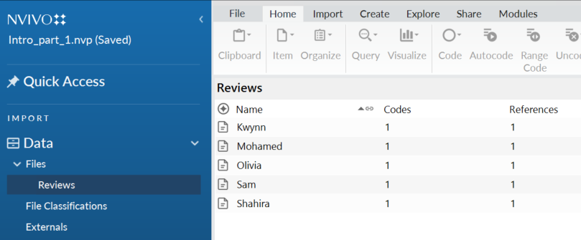
To read the content of your files:

- Click on Files > Reviews in the Navigation View. This will show the list of reviews in the List View

- Double click on the first file. This will open the text for this review in the Details View.

Note, that you can edit the text at this point by selecting the edit check box.

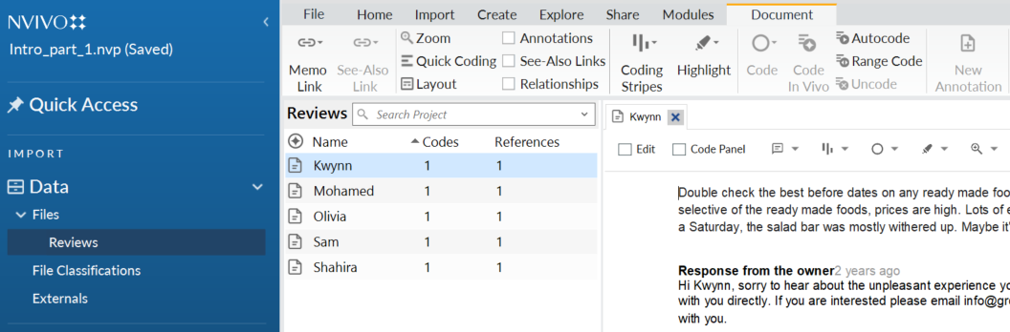

As you read through each review, themes will begin to reveal themselves. For example, some of the themes the first review reveals include:
- expired food
- over packaging
- helpful employees.
You will create these codes, and when you have completed the first review you will move to the next. As you make your way through the reviews, you will find that you create fewer new codes, and instead start adding to the codes you created in earlier reviews. Furthermore, as you move along you might decide that you want to rename, or even merge codes.

Create a new code
There are 3 methods to create codes in NVivo: drag and drop, right-click, and using the codes panel. Choose one of the methods listed in step 3 below.

- Click on Coding > Codes in the Navigation View
- Close the information window
- Use your mouse to highlight a block of text in the Details View, and do one of the following:
  - Drag the text to the List View > create a code using the dialogue box, or
  - Right click > Code Selection > New code > create a code using the dialogue box, or
  - Click on the code icon > create a code using the dialogue

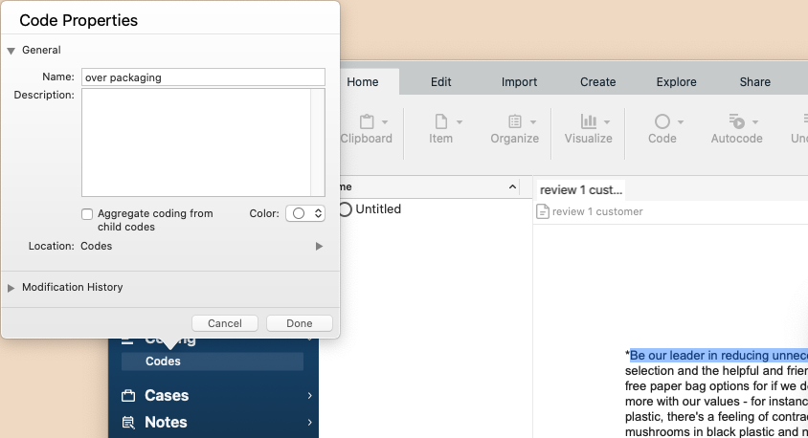

Add to an existing code(s):
- Use your mouse to highlight a block of text in the Details View, and do one of the following:
  - Drag and drop the text to an existing code in the List View, or
  - Right click > Code Selection > To existing codes or cases> check the box next to the code or codes that apply, or
  - Click on the code icon > To existing codes or cases> check the box next to the code or codes that apply
- Close the review 1 customer in the Detail View (optional)

Switch to the next record
- Click on Files in Navigation View
- Double click on review 2 customer
- Continue coding the remaining records.

Coding Stripes
Coding stripes allow you to easily browse your codes within your text. This is especially useful when you are working with long documents.
- With the text of your document open, click on the coding stripe icon
- Select All and Automatic Colour
Note you can experiment with the settings to focus on particular codes.

Examining the codes panel
As you create new, and add to existing codes, the codes panel will keep track of how many files belong to each code, and how many total references (there can be multiple references within a single file) there are for each code.

To view your codes panel:
- Close the customer review content by clicking on the x on each tab.
- Click on Codes in the navigation window
Note: your panel might look different than mine as coding is subjective, and we may have coded things differently.

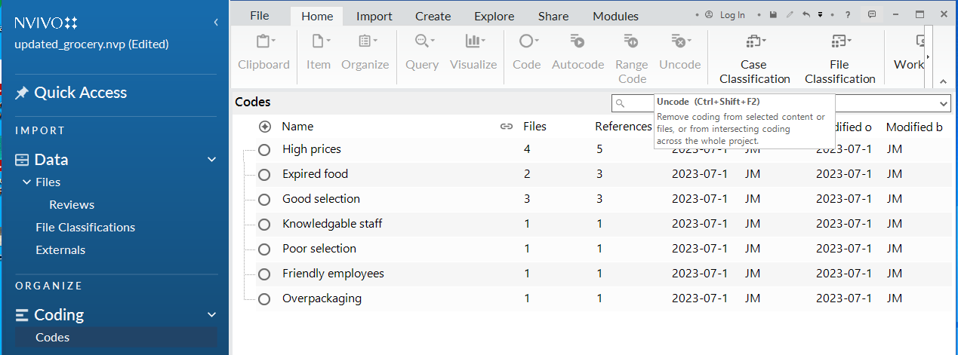
This gives a good snapshot of emerging trends. For example, we can see that high prices is a common trend. It showed up in 4 of our files and was referenced 5 times.

Merging codes and renaming
You will find that as you code, you might end up with codes that are too similar to each other. It is good practice to regularly go through your codes and merge the ones that are conceptually similar. For example, you can see above that I have two related codes: knowledgeable staff, and friendly employees. We would like to merge them together and then rename it to helpful employees:

- Right click on the code you want to dissolve, in this case Knowledgeable staff, and:
- Mac: copy
- Windows: cut
- Right click on the code you want to merge in to, in this case friendly employees, and:
- Mac: merge in to selected code
- Windows: same
- Right click on the first code (pleasant individuals) > delete (Mac)
- To rename to helpful employees:
  - Mac: right click > info
  - Windows: click once on code name and type change

Deleting codes
You may decide to remove codes that have very few references. In this example I will delete over packaging

- Right click on the code you want to delete > Delete

Viewing codes
Double click on one of the codes in the code panel to view the Summary or Reference related to each code 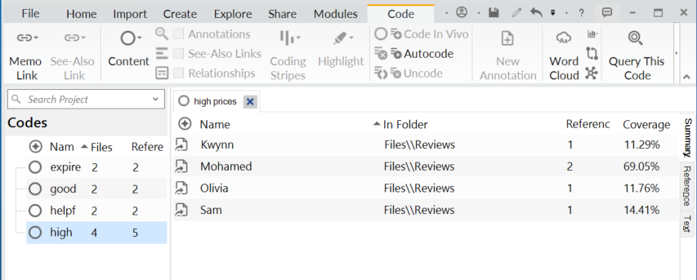

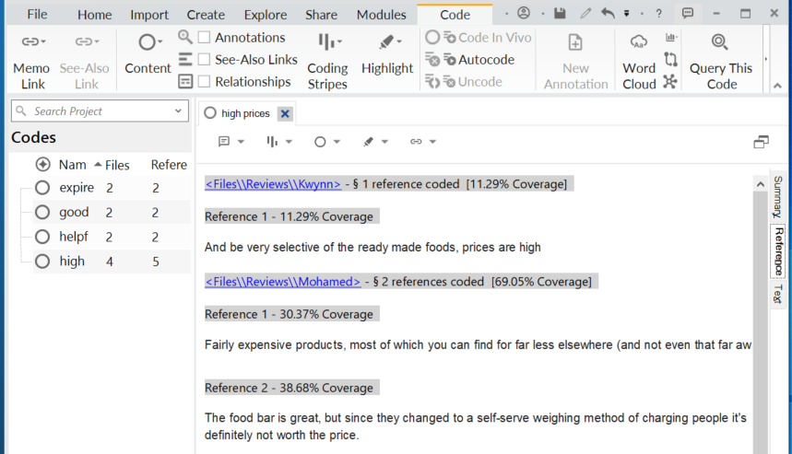

Creating Code Hierarchies / aggregating codes
NVivo recommends following the catalogue system of coding which uses hierarchies. Please watch the following video before you embark on your own project https://youtu.be/xTEmOJZPbQI

Creating hierarchies allows you to better organise your codes. This is particularly useful if you have a lot of codes that can be grouped into themes. In our example, we have a number of codes that represent positive and negative feedback. We will organise our codes into these two themes by creating parent codes. Codes assigned to a parent code are called child codes. Let’s create two parent codes: Positive Feedback, and Negative Feedback.

- Click on Codes in the Navigation View
- Right click on the empty space
  - Mac: New Top-level code > type POSITIVE FEEDBACK
  - Windows: New code > type POSITIVE FEEDBACK
- Repeat for NEGATIVE FEEDBACK
- Drag and drop the negative codes into NEGATIVE FEEDBACK
- Drag and drop the positive codes into POSITIVE FEEDBACK.
The results will look something like below.
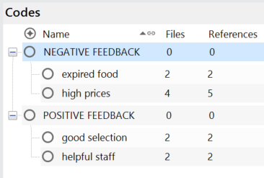

Note that the number of files, and references are zero for the parent codes. To rectify this:

- Right click on NEGATIVE FEEDBACK > Aggregate Coding from Child Codes
- Right click on POSITIVE FEEDBACK> Aggregate Coding from Child Codes

Note: your numbers may be different than seen here depending upon how you coded. What is important is that the child numbers add up to the parent number:

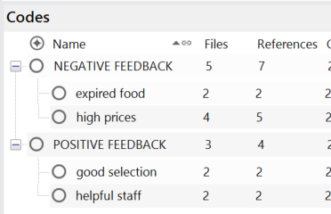

Good to know:
- Rename a code by right clicking on the code > code properties
- You can code a block of text to more than one code use the right click method and choose code selection to see the list of codes >use the CTRL or CMD key select all relevant codes > code selection to multiple items
- You cannot duplicate coding the same passage to the same code
- You can uncode from within a text or from within a code https://youtu.be/hDZjBOxAV-Q
- Coding audio/video timelines with synchronised transcripts https://youtu.be/7dnocy0qkKc
- Coding images https://youtu.be/0GiMJ7hxhgg
- Automatic coding using structure and style can be used for structured or semistructured interviews / surveys https://youtu.be/wzXZSPz6EbE
- Automatic coding to identify themes identifies keywords. This is not a substitute for human interpretation of concepts https://youtu.be/tggueNg_62E

Notes - Memos
These are a type of document that allows you to record ideas, insights, interpretations or growing understanding of your material – kind of like a notepad that you might jot thoughts into. Memos can be linked to specific content in your project, or they can exist as standalone notes. For example:

- Files – capture any issues or insights that might arise
- Codes – describe the significance of the code and patterns or ideas that emerge from the different references
- Cases – insight on a specific person that was unique to the interview ie) they were agitated.
- Queries – attached to the query results – what does the query tell me..
- Unlinked – store information that is not linked to anything specific – this might include your research objectives or progress

Memos can only be linked to one item.

Create an project memo:

- Click on Notes in the Navigation View
- Right click on Memos > New Memo
- Enter the name “project methodology” and any description of desired > Ok
- Uncheck Edit and add information to your Memo.

Create a linked memo:

- Select file, code, case or external in the List view
- Right click on item > Memo Link > Link to New Memo
- Enter a memo name
- Uncheck Edit and add information to your Memo.

All of the notes that you create can be found in the Notes section of the Navigation View.

Queries
Queries help you to explore your data and investigate hunches as you progress through your project. NVivo queries offer a flexible approach to exploring your data—you can create quick and simple queries to get a sense of what is happening in the data or you can build detailed queries for a more focused perspective.

Text Search
The text search query allows you to find all occurrences of a word, phrase or concept. This is useful for multiple scenarios.

- Click on Explore > Text Search
- Enter the word “price”
- Select the location in which you wish to search. In our case we will choose Files and External
- Choose “include stemmed words” to get variations on the word price (ie: prices, pricing..)

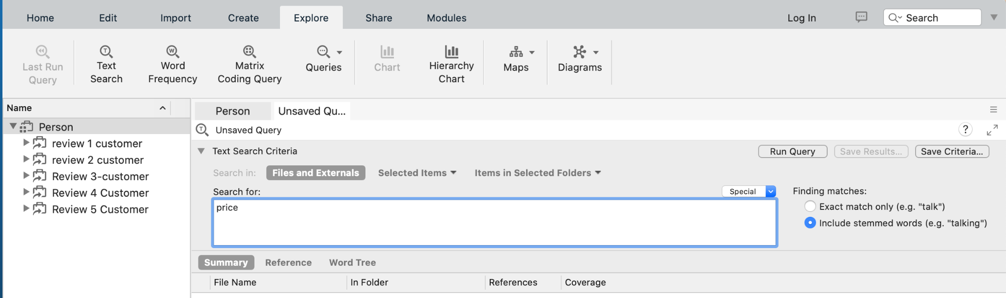

- Click on Run Query. You will be presented with the results which you can view as Summary, Reference, Text, Word Tree.
- Double click on one of the reviews or click on the different tabs to interact with your search results.

Note: you can save any of your queries for future reference by clicking on Save Results. They will then be stored under Queries in the Navigation View.

Word Frequency
Explore the most frequently occurring words in your files. This is another way to look for interesting trends in your data.
- Click on Explore > Word Frequency
- Select the location in which you wish to search. In our case we will choose Files and External
- Choose “include stemmed words” to get variations on words
- Click Run Query

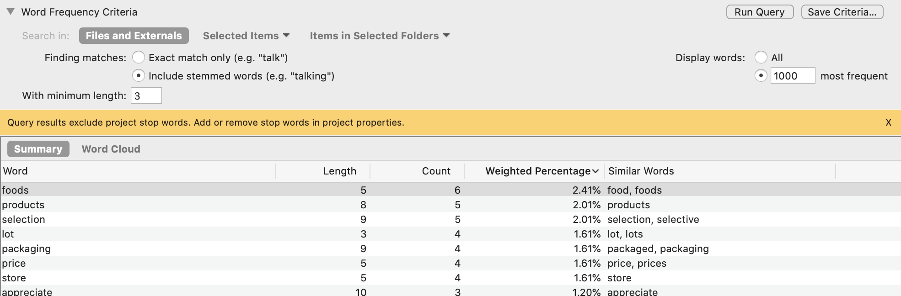

- View your results via Summary or Word Cloud

Visualisations
NVivo provides lots of options to visualise trends and patterns in your data. We will examine these in Part 2 of workshop.

Take some time to review the videos below to see what you can do.

Hierarchy chart (tree maps) of codes - illustrates which codes are more heavily used https://youtu.be/rObahpTnIbw
Chart coding by attribute value - breaks down coding to a thematic code by an attribute value https://youtu.be/NKvcNGUmbxY
Comparison diagrams - compare files, codes or cases https://youtu.be/fybS5WMAGAY
Cluster analysis of themes - exploratory technique to find patterns in word, coding or attribute similarity https://youtu.be/AY3s8qe0KVQ
Explore Diagrams Codes and Files - show connections among files, codes and cases which vary by the focus item https://youtu.be/cPavz8YnTb0
Word Clouds - visualise frequently used words https://youtu.be/uYJdkrkpmIA

Further Help
Getting Started NVIVO YouTube https://www.youtube.com/playlist?list=PLNjHMRgHS4Fc7-Bk0K5PR9rtRyGdFfNpu

